Day 33 API Endpoints and API parameters

<https://www.udemy.com/course/100-days-of-code/learn/lecture/21198550#overview>

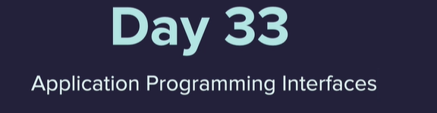

App to check if International Space Station is over head

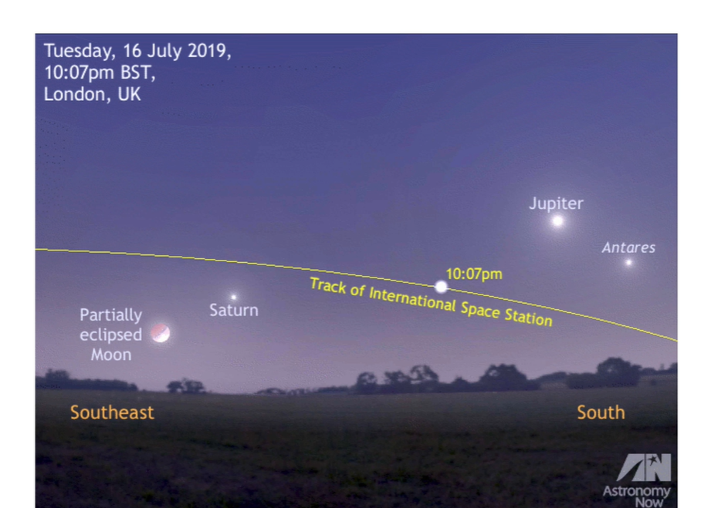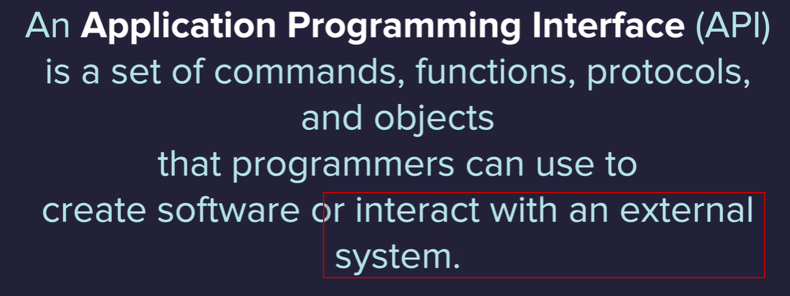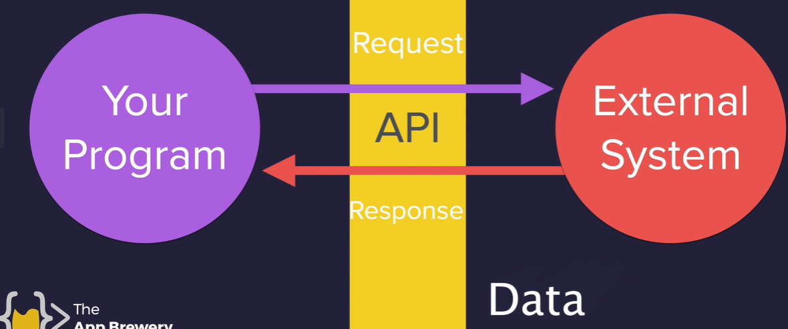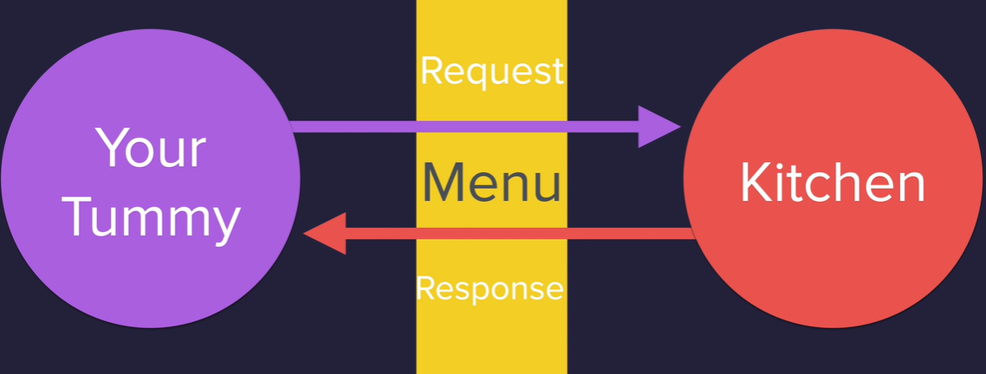

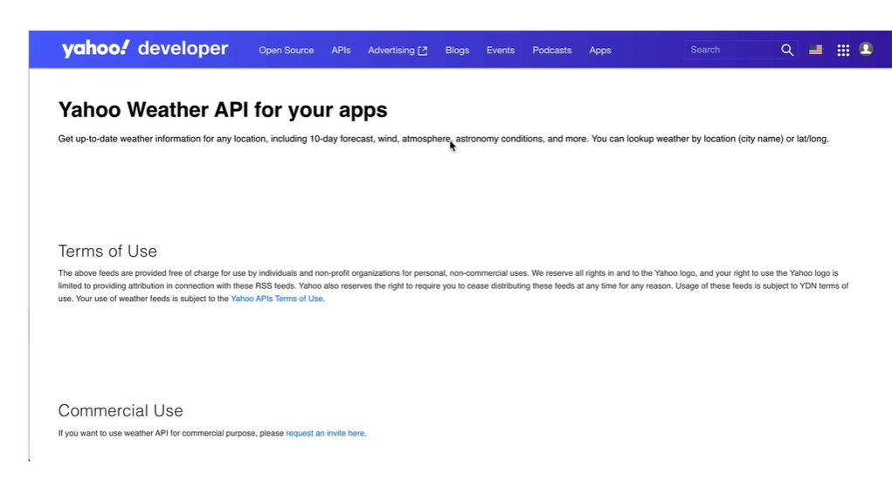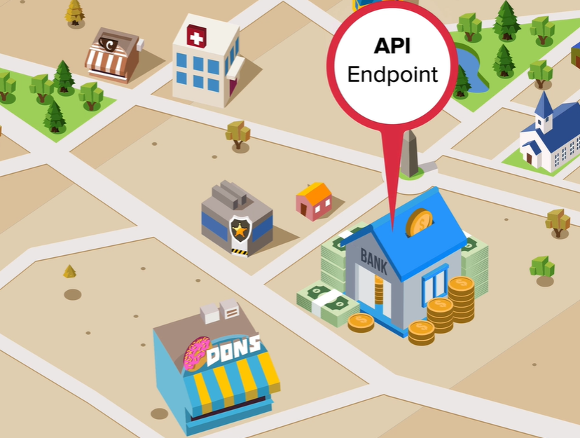

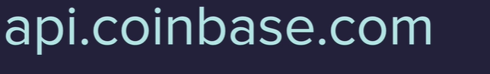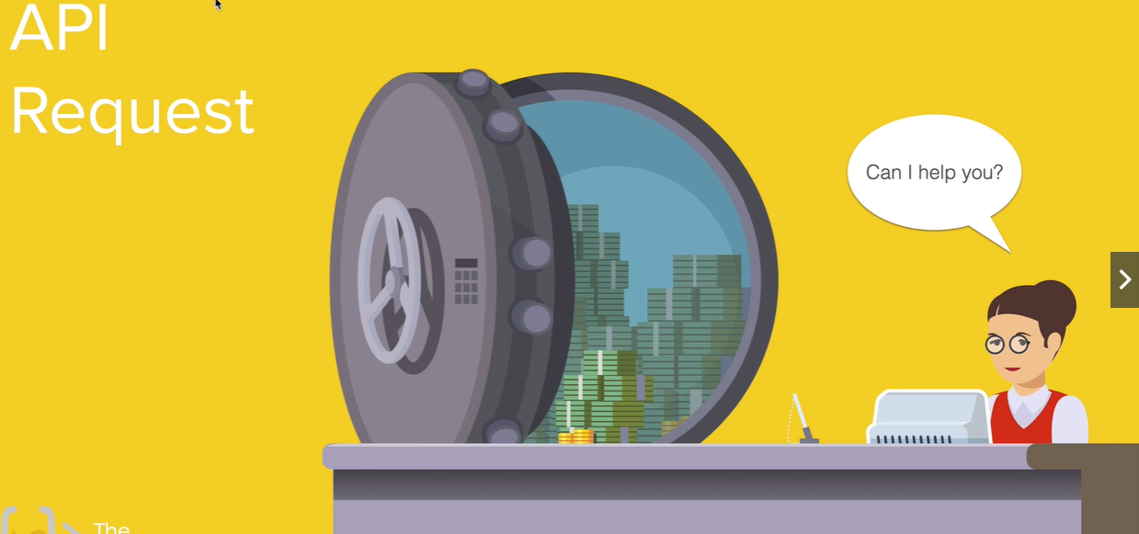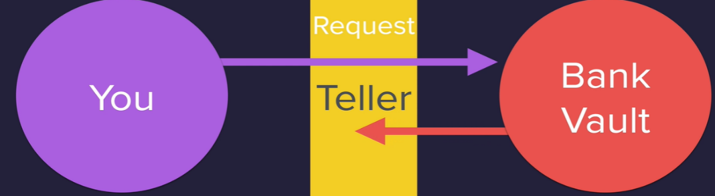

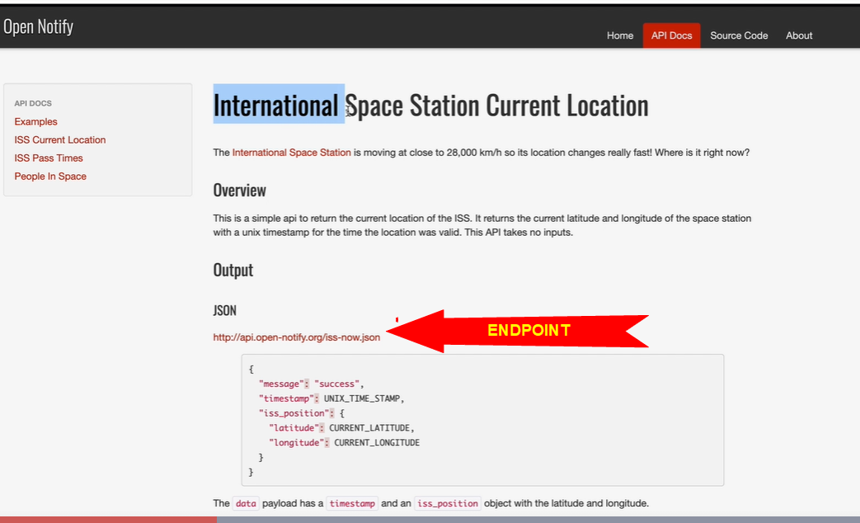

http://open-notify.org/Open-Notify-API/ISS-Location-Now/

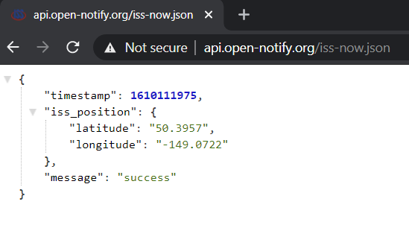

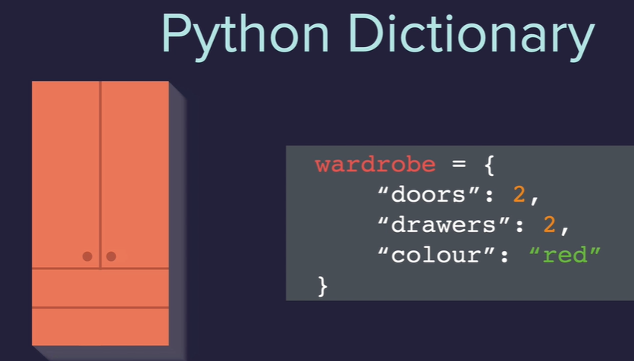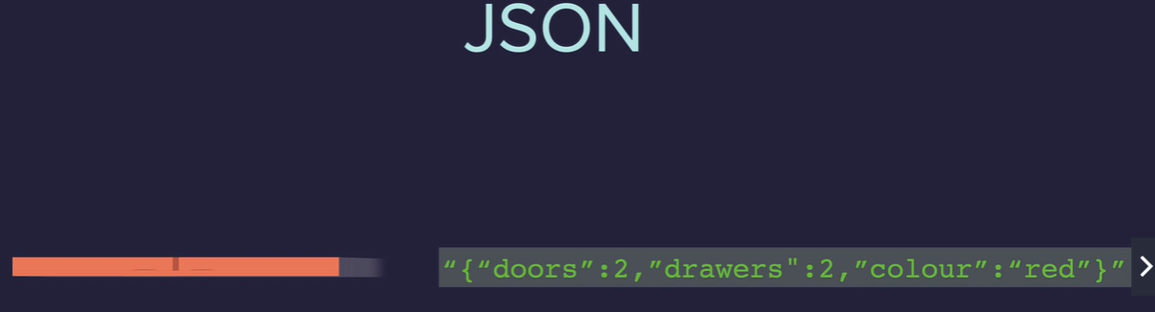

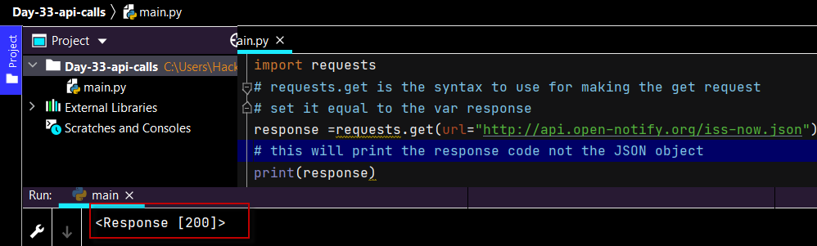

Requests module docs

<https://requests.readthedocs.io/en/master/user/quickstart/>

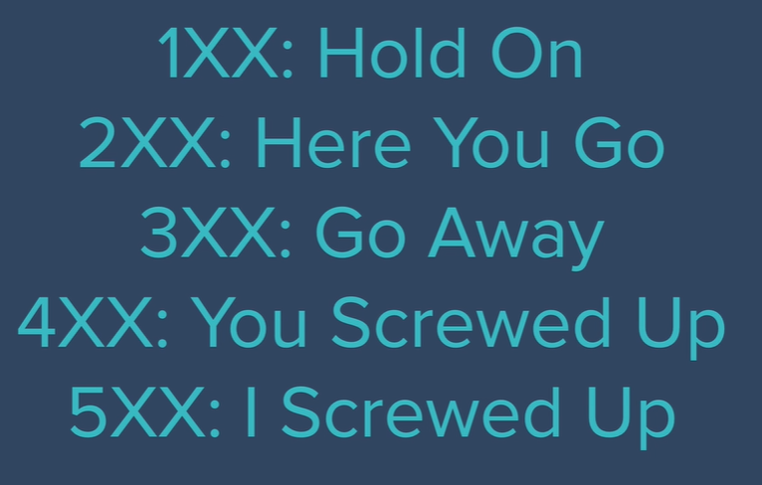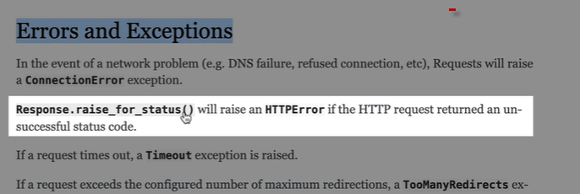

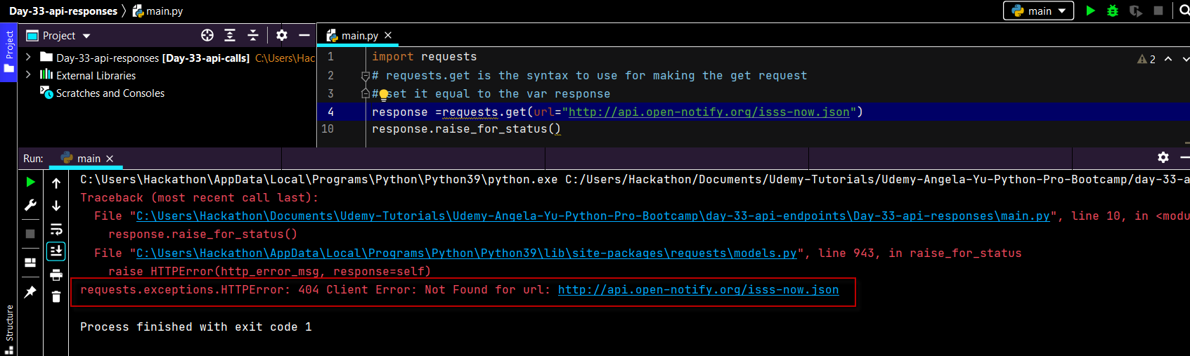

<https://www.latlong.net/Show-Latitude-Longitude.html>

GET request

import requests  
# requests.get is the syntax to use for making the get request  
# set it equal to the var response  
response =requests.get(url="http://api.open-notify.org/iss-now.json")  
# this will print the response code not the JSON object  
# print(response)  
# # print just the response code  
# print(response.status_code)  
# use the requests module  
response.raise_for_status()  
# to get the actual data  
data = response.json()  
# can drill down into data as would a python dictionary - here passing in key  
position = response.json()["iss_position"]  
# here drilling down further  
longitude = response.json()["iss_position"]["longitude"]  
latitude = response.json()["iss_position"]["latitude"]  
print(f"{data}\n{position}\n{longitude}\n{latitude}\n")  
# making a tupple  
iss_position = (latitude**,**longitude)  
print (iss_position)

Kanye Quotes App

<https://kanye.rest/>

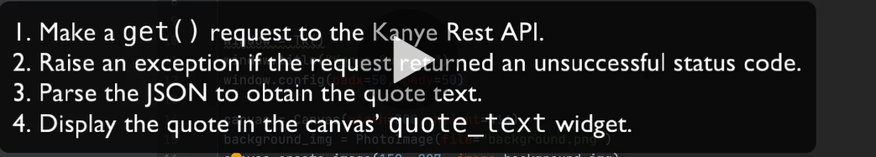

from tkinter import *  
import requests  
quote_text = "Click my head for a quote"  
def get_quote():  
 #Write your code here.  
 response = requests.get("https://api.kanye.rest")  
 response.raise_for_status()  
 data = response.json()  
 # print(data)  
 quote= data["quote"]  
 # print(quote_text)  
 canvas.itemconfig(quote_text**,** text =quote)  
  
  
window = Tk()  
window.title("Kanye Says...")  
window.config(padx=**50,** pady=**50**)  
  
canvas = Canvas(width=**300,** height=**414**)  
background_img = PhotoImage(file="background.png")  
canvas.create_image(**150, 207,** image=background_img)  
quote_text = canvas.create_text(**150, 207,** text=quote_text**,** width=**250,** font=("Arial"**, 20,** "bold")**,** fill="white")  
canvas.grid(row=**0,** column=**0**)  
  
kanye_img = PhotoImage(file="kanye.png")  
kanye_button = Button(image=kanye_img**,** highlightthickness=**0,** command=get_quote)  
kanye_button.grid(row=**1,** column=**0**)

passing in parameters

<https://www.w3schools.com/python/ref_string_split.asp>

<https://sunrise-sunset.org/api>

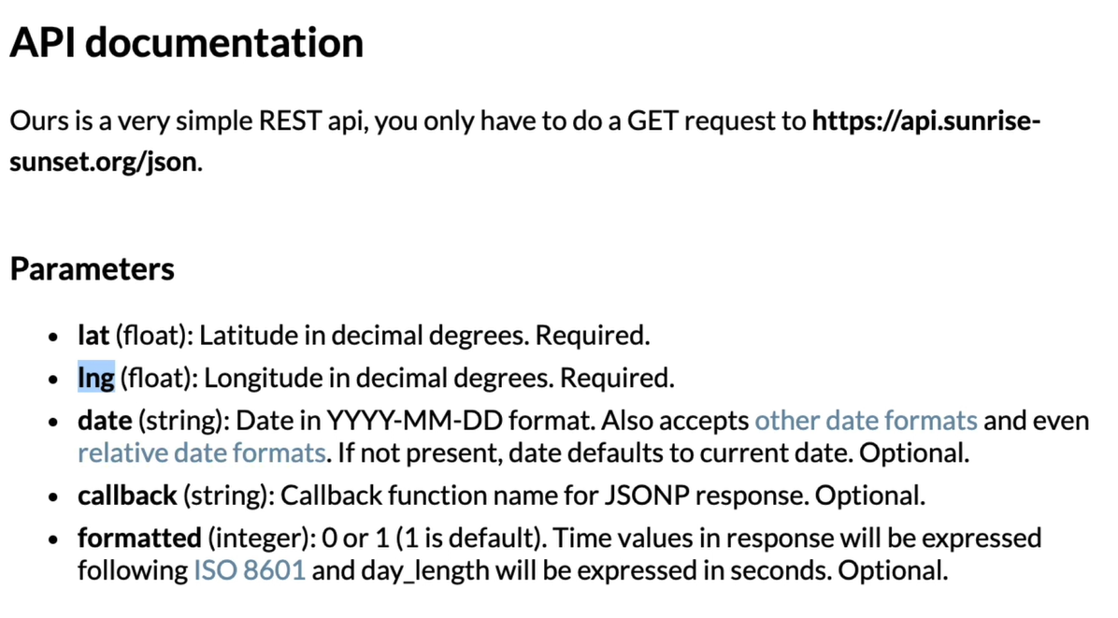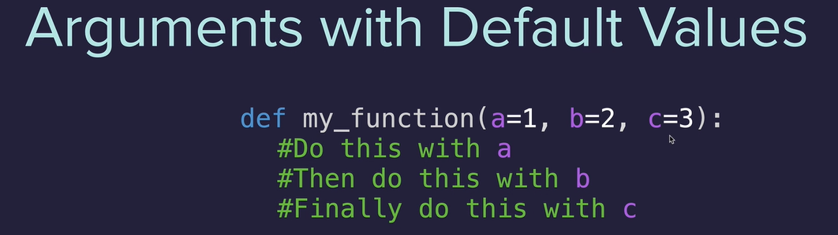

Sunrise sunset api

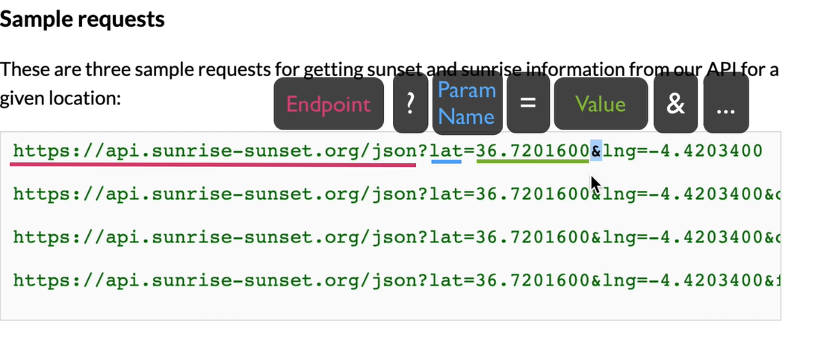

If it is nighttime and the ISS is overhead send email to look up 